Music
Curriculum Progression



Subject Leader: Mrs Howle
Academic Year: 2025-2026

Our School Mission
We Believe, We Succeed and We Soar
Christ is at the centre of St. Mary’s as we strive to nurture and care for our community and encourage them to Believe, Succeed and Soar. Through God’s love, we support our pupils in recognising their God given gifts, strengthening their work as missionary disciples.
‘Do little things with great love’ St Therese of Lisieux
The mission of St Mary’s Catholic Voluntary Academy is that of Jesus Christ; to build a teaching and learning community where we show due regard for the development and understanding of the uniqueness and dignity of each person. At St Mary’s, each child is valued as a unique individual, a child of God, made in the image of the Father, Son and Holy Spirit.

Our Gospel Values
With God’s love we show:

Love
‘My command is this: Love one another as I have loved you.’ John 15:12
We recognise God’s unconditional love to be our source of love. A Christ-like love respects the talent of each person in our school.

Respect
‘In everything, then do to others as you would have them do to you.’ Matthew 7:12
We believe that, as children of God, we have a duty not only to respect our friends and teachers but also to show respect to our environment as we are stewards of the earth.

Honesty
‘Dear children, let us not love with words or speech but with actions and in truth.’ 1 John 3:18
We show honesty in all we say and do, in the pursuit of justice and fairness.

Forgiveness
‘Do not judge, and you will not be judged. Do not condemn, and you will not be condemned. Forgive, and you will be forgiven.’ Luke 6:37
We believe that mercy will be shown by the way we forgive others, finding God in all things.

Generosity
‘It is more blessed to give than to receive.’ Acts 20:35
Just as Jesus washed the feet of his disciples, we have a role to serve our neighbours and the wider community. Through fundraising and prayer, we will strive to help the people in our world, our common home.

Patience
‘Jesus replied, ‘You do not realise now what I am doing, but later you will understand.’ John 13:7
We remember to be patient and trust in God as we know he has a much greater plan for us. He allows us to be tested so that we learn to walk in his ways and trust in him.

Music Progression of Knowledge and Skills

Singing

The following principles should be kept in mind as pupils develop their vocal potential through the Key Stages:
- Warm ups will help pupils use their voices safely. There are many places to find good examples of vocal warmups, and they will typically include vocalising, sirening and simple scales, as well as games to energise pupils.
- Breathing. Increasing control of airflow will help pupils to sing longer phrases, adjust dynamics, improve tuning and phrase melodies expressively.
- Posture. A relaxed but stable stance (soft knees) sets the body up to produce an unforced but well-focused sound. Pupils, especially younger pupils, will often want to move to the music and this helps to facilitate that.
- Dynamics. When appropriate, class singing should include a dynamic range as a key expressive tool. Confident singing will often be loud but need not tip over into shouting.
- Phrasing gives shape to melodic lines. Through small dynamic changes, it helps emphasise important syllables and create musical interest in the melody.
- Context. Music can often be brought to life by considering the context in which it was written, or by discussing the meaning of any words.
- Vocal health. Warming up before singing, staying hydrated, resting voices, particularly when there is lots of singing to do, keeping vocal muscles relaxed
EYFS | Pupils will:  - Begin singing in unison  - Be able to ‘rap’ nursery rhymes
Year 1 | Pupils will:  - Sing simple songs, chants and rhymes (e.g. Boom Chicka Boom) from memory, singing collectively and at the same pitch, responding to simple visual directions (e.g. stop, start, loud, quiet) and counting in.  - Begin with simple songs with a very small range, mi-so (e.g. Hello, How are You), and then slightly wider (e.g. Bounce High, Bounce Low). Include pentatonic songs (e.g. Dr Knickerbocker).  - Sing a wide range of call and response songs (e.g. Pretty Trees Around the World from Rhythms of Childhood), to control vocal pitch and to match the pitch they hear with accuracy
Year 2 | Pupils will:  - Sing songs regularly with a pitch range of do-so with increasing vocal control.  - Sing songs with a small pitch range (e.g. Rain, Rain Go Away), pitching accurately.  - Know the meaning of dynamics (loud/quiet) and tempo (fast/slow) and be able to demonstrate these when singing by responding to (a) the leader's directions and (b) visual symbols (e.g. crescendo, decrescendo, pause)
Year 3 | Pupils will:  - Sing a widening range of unison songs of varying styles and structures with a pitch range of do–so (e.g. Extreme Weather), tunefully and with expression. Perform forte and piano, loud and soft.  - Perform actions confidently and in time to a range of action songs (e.g. Heads and Shoulders).  - Walk, move or clap a steady beat with others, changing the speed of the beat as the tempo of the music changes.  - Perform as a choir in school assemblies.
Year 4 | Pupils will:  - Continue to sing a broad range of unison songs with the range of an octave (do–do) (e.g. One More Day–a traditional sea shanty) pitching the voice accurately and following directions for getting louder (crescendo) and quieter (decrescendo).  - Sing rounds and partner songs in different time signatures (2, 3 and 4 time) (e.g. Our Dustbin) and begin to sing repertoire with small and large leaps as well as a simple second part to introduce vocal harmony (e.g. Hear the Wind).  - Perform a range of songs in school assemblies
Year 5 | Pupils will:  - Sing a broad range of songs from an extended repertoire with a sense of ensemble and performance. This should include observing phrasing, accurate pitching and appropriate style.  - Sing three-part rounds, partner songs, and songs with a verse and a chorus.  - Perform a range of songs in school assemblies and in school performance opportunities
Year 6 | Pupils will:  - Sing a broad range of songs, including those that involve syncopated rhythms, as part of a choir, with a sense of ensemble and performance. This should include observing rhythm, phrasing, accurate pitching and appropriate style.  - Continue to sing three- and four-part rounds (e.g. Calypso by Jan Holdstock) or partner songs, and experiment with positioning singers randomly within the group – i.e. no longer in discrete parts – in order to develop greater listening skills, balance between parts and vocal independence.  - Perform a range of songs as a choir in school assemblies, school performance opportunities and to a wider audience.
Composing
The creative process, with its wide horizons of possibility, gives pupils an opportunity to contribute to musical culture in unique and valuable ways. As pupils travel through the Key Stages, they will develop the craft of creating melodies and fashioning these into short pieces. Familiarity with music in a range of styles and genres is crucial for developing the aural understanding needed to compose music. It is also worth planning the year so that music listened to and performed is linked and that both of these activities inform pupils’ composition. The development of a reliable musical memory is a valuable skill for performers and composers. As an integral part of composition work, pupils should practise recalling, e.g., melodic shapes, harmonic sequences, rhythmic patterns and sections of their compositions.
EYFS | Pupils will:  - Play untuned percussion instruments  - Be able to improvise rhythms on tuned instruments  - Begin to make up their own rhythms using words  - Compose music as a class using a graphic score and play that music
Year 1 | Pupils will:  - Improvise simple vocal chants, using question and answer phrases.  - Create musical sound effects and short sequences of sounds in response to stimuli, e.g. a rainstorm or a train journey. Combine to make a story, choosing and playing classroom instruments (e.g. rainmaker) or sound-makers (e.g. rustling leaves).    - Understand the difference between creating a rhythm pattern and a pitch pattern. • Invent, retain and recall rhythm and pitch patterns and perform these for others, taking turns.  - Use music technology, if available, to capture, change and combine sounds.  - Recognise how graphic notation can represent created sounds. Explore and invent own symbols, for example:
Year 2 | Pupils will:  - Create music in response to a non-musical stimulus (e.g. a storm, a car race, or a rocket launch).  - Work with a partner to improvise simple question and answer phrases, to be sung and played on untuned percussion, creating a musical conversation.  - Use graphic symbols, dot notation and stick notation, as appropriate, to keep a record of composed pieces.  - Use music technology, if available, to capture, change and combine sounds.
Year 3 | Pupils will:  - Become more skilled in improvising (using voices, tuned and untuned percussion and instruments played in whole-class/group/individual/instrumental teaching), inventing short ‘on-the-spot’ responses using a limited note-range.  - Structure musical ideas (e.g. using echo or question and answer phrases) to create music that has a beginning, middle and end. Pupils should compose in response to different stimuli, e.g. stories, verse, images (paintings and photographs) and musical sources.  - Combine known rhythmic notation with letter names to create rising and falling phrases using just three notes (do, re and mi).  - Compose song accompaniments on untuned percussion using known rhythms and note values.
Year 4 | Pupils will:  - Improvise on a limited range of pitches on the instrument they are now learning, making use of musical features including smooth (legato) and detached (staccato).  - Begin to make compositional decisions about the overall structure of improvisations. Continue this process in the composition tasks below.  - Combine known rhythmic notation with letter names to create short pentatonic phrases using a limited range of 5 pitches suitable for the instruments being learnt. Sing and play these phrases as self-standing compositions.  - Arrange individual notation cards of known note values (i.e. minim, crotchet, crotchet rest and paired quavers) to create sequences of 2-, 3- or 4-beat phrases, arranged into bars.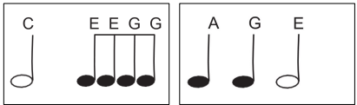  - Explore developing knowledge of musical components by composing music to create a specific mood, for example creating music to accompany a short film clip.  - Introduce major and minor chords.  - Include instruments played in whole-class/group/individual teaching to expand the scope and range of the sound palette available for composition work.  - Capture and record creative ideas using any of: o graphic symbols o rhythm notation and time signatures o staff notation o technology.
Year 5 | Pupils will:  - Improvise freely over a drone, developing sense of shape and character, using tuned percussion and melodic instruments.  - Improvise over a simple groove, responding to the beat, creating a satisfying melodic shape; experiment with using a wider range of dynamics, including very loud (fortissimo), very quiet (pianissimo), moderately loud (mezzo forte), and moderately quiet (mezzo piano). Continue this process in the composition tasks below.  - Compose melodies made from pairs of phrases in either C major or A minor or a key suitable for the instrument chosen. These melodies can be enhanced with rhythmic or chordal accompaniment.  - Working in pairs, compose a short ternary piece.  - Use chords to compose music to evoke a specific atmosphere, mood or environment. For example, La Mer by Debussy and The River Flows In You by Yiruma both evoke images of water. Equally, pupils might create music to accompany a silent film or to set a scene in a play or book.  - Capture and record creative ideas using any of: graphic symbols, rhythm notation and time signatures, staff notation, technology
Year 6 | Pupils will:  - Extend improvisation skills through working in small groups to:  - Create music with multiple sections that include repetition and contrast.  - Use chord changes as part of an improvised sequence.  - Extend improvised melodies beyond 8 beats over a fixed groove, creating a satisfying melodic shape.  - Plan and compose an 8- or 16-beat melodic phrase using the pentatonic scale (e.g. C, D, E, G, A) and incorporate rhythmic variety and interest. Play this melody on available tuned percussion and/or orchestral instruments. Notate this melody.  - Compose melodies made from pairs of phrases in either G major or E minor or a key suitable for the instrument chosen.  - Either of these melodies can be enhanced with rhythmic or chordal accompaniment.  - Compose a ternary piece; use available music software/apps to create and record it, discussing how musical contrasts are achieved.
Listening and Appraising
Listening to music is fundamental to musical understanding. By learning to listen critically, pupils will not only expand their musical horizons but also gain a deeper understanding of how music is constructed and the impact it can have on the listener. Listening to a broad range of music also helps develop other areas of musical activity, including composing and performing.
The teaching and learning of music is enriched by developing pupils’ knowledge and understanding of the stories, origins, traditions, history and social context of the music they are listening to, singing and playing. Listening to recorded performances is complemented by opportunities to experience live music making in and out of school.
EYFS | Pupils will:  - Listen attentively and move to music  - Talk about music, expressing their opinions  - Notice what other children and adults do, mirror what is observed, adding variations and doing it spontaneously  Respond imaginatively to music e.g. this music sounds like dinosaurs
Year 1 | Pupils will:  - Listen to sounds in the local school environment, comparing high and low sounds.  - Respond to different moods of music, in different ways  - Say how a piece of music makes them feel  Begin to describe how sounds are made and changed
Year 2 | Pupils will:  - Begin to say what they like and dislike and why  - Verbally recall what they have heard with simple vocabulary – loud, soft, high, low  Begin to associate sounds they hear with instruments
Year 3 | Pupils will:  - Identify the features within a piece of music  - Describe music using appropriate vocabulary  - Recognise a range of instruments by ear  - Know that music can be played or listened to for a variety of purposes  Recognise differences between music of different times and cultures
Year 4 | Pupils will:  - Explore ways the way in which sounds are combined towards certain effects.  - Describe the different purposes of music  - Be able to describe how the purpose of music can affect the style  Compare and contrast the work of established composers and show preferences
Year 5 | Pupils will:  - Describe and compare different kinds of music using an appropriate and broad musical vocabulary  - Compare features from a wide range of music  - Distinguish between layers of sound in a piece of music  Compare and contrast the impact that different composers from different times will have had on the people of the time
Year 6 | Pupils will:  - Describe, compare and evaluate different kinds of music using an appropriate and broad musical vocabulary  - Distinguish between layers of sound in a piece of music and evaluate the effects  Be able to describe how the purpose of music can affect the style, for instance in Early music, for religious purposes, or for entertainment
Musicianship – Pulse/Beat
EYFS | Pupils will:  - Learn the meaning of the word ‘beat’ in music  - Clap along to a steady beat
Year 1 | Pupils will:  - Walk, move or clap a steady beat with others, changing the speed of the beat as the tempo of the music changes.  - Use body percussion, (e.g. clapping, tapping, walking) and classroom percussion (shakers, sticks and blocks, etc.), playing repeated rhythm patterns (ostinati) and short, pitched patterns on tuned instruments (e.g. glockenspiels or chime bars) to maintain a steady beat.  - Respond to the pulse in recorded/live music through movement and dance, e.g. o Stepping (e.g. Mattachins from Capriol Suite by Warlock), o Jumping (e.g. Trepak from The Nutcracker by Tchaikovsky) o Walking on tiptoes (e.g. Scherzo from The Firebird Suite by Stravinsky).
Year 2 | Pupils will:  - Understand that the speed of the beat can change, creating a faster or slower pace (tempo).  - Mark the beat of a listening piece (e.g. Bolero by Ravel) by tapping or clapping and recognising tempo as well as changes in tempo.  - Walk in time to the beat of a piece of music or song (e.g. La Mourisque by Susato). Know the difference between left and right to support coordination and shared movement with others.  - Begin to group beats in twos and threes by tapping knees on the first (strongest) beat and clapping the remaining beats.  - Identify the beat groupings in familiar music that they sing regularly and listen to, e.g. o in 2 Maple Leaf Rag by Joplin o in 3 The Elephant from Carnival of the Animals by Saint-Saëns
Musicianship – Rhythm
EYFS | Pupils will:  - Know the meaning of the word ‘rhythm’  - Be able to clap rhythms by repeating  - Copy rhythms on untuned instruments
Year 1 | Pupils will:  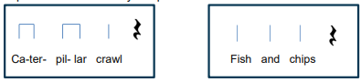  - Perform short copycat rhythm patterns accurately, led by the teacher.  - Perform short repeating rhythm patterns (ostinati) while keeping in time with a steady beat.  - Perform word-pattern chants (e.g. ca-ter-pil-lar crawl, fish and chips); create, retain and perform their own rhythm patterns.
Year 2 | Pupils will:  - Play copycat rhythms, copying a leader, and invent rhythms for others to copy on untuned percussion.  - Create rhythms using word phrases as a starting point (e.g. Hel-lo Si-mon or Can you come and play?).  - Read and respond to chanted rhythm patterns, and represent them with stick notation including crotchets, quavers and crotchets rests.  - Create and perform their own chanted rhythm patterns with the same stick notation.
Musicianship – Pitch
EYFS | Pupils will:  - Know the difference between high and low sounds
Year 1 | Pupils will:  - Sing familiar songs in both low and high voices and talk about the difference in sound.  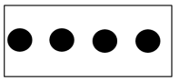  - Explore percussion sounds to enhance storytelling, e.g. ascending xylophone notes to suggest Jack climbing the beanstalk, quiet sounds created on a rainstick/shakers to depict a shower, regular strong beats played on a drum to replicate menacing footsteps.  - Follow pictures and symbols to guide singing and playing, e.g. 4 dots = 4 taps on the drum.
Year 2 | Pupils will:  - Play a range of singing games based on the cuckoo interval (so-mi, e.g. Little Sally Saucer) matching voices accurately, supported by a leader playing the melody. The melody could be played on a piano, acoustic instrument or backing track.  - Sing short phrases independently within a singing game or short song.    - Respond independently to pitch changes heard in short melodic phrases, indicating with actions (e.g. stand up/sit down, hands high/hands low).  - Recognise dot notation and match it to 3-note tunes played on tuned percussion, for example:
Performing
Creating opportunities to celebrate, share and experience music of all kinds will consolidate the learning within the music curriculum.

The following principles of performance apply across all Key Stages:
- Develop stagecraft. Develop a sense of confidence and ownership regardless of the size or nature of the stage or performing/recording space; engage with an audience; respect fellow performers and acknowledge applause.
- Consider the programme. The sequence of items should maximise impact and maintain audience engagement. Aim for a clear beginning, middle and end for any performance activity.
- Encourage peer feedback. Create an environment where pupils can constructively express their thoughts on performances. This is a valuable way to develop listening skills and musical vocabulary.
- Seek out opportunities for collaboration. If more than one class or group is performing, is there an additional item they can present together?
Year 3 | Pupils will:  - Develop facility in playing tuned percussion or a melodic instrument such as violin or recorder. Play and perform melodies following staff notation using a small range (e.g. Middle C–E/do–mi) as a whole class or in small groups (e.g. trios and quartets).  - Use listening skills to correctly order phrases using dot notation, showing different arrangements of notes C-D-E/do-re-mi (see illustration):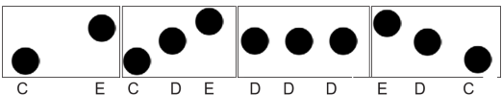  - Individually (solo) copy stepwise melodic phrases with accuracy at different speeds; allegro and adagio, fast and slow. Extend to question-and-answer phrases.
Year 3 | Pupils will:  - Develop facility in the basic skills of a selected musical instrument over a sustained learning period. This can be achieved through working closely with your local Music Education Hub who can provide whole-class instrumental teaching programmes.  - Play and perform melodies following staff notation using a small range (e.g. Middle C–G/do–so) as a whole-class or in small groups.  - Perform in two or more parts (e.g. melody and accompaniment or a duet) from simple notation using instruments played in whole class teaching. Identify static and moving parts.  - Copy short melodic phrases including those using the pentatonic scale (e.g. C, D, E, G, A)
Year 5 | Pupils will:  - Play melodies on tuned percussion, melodic instruments or keyboards, following staff notation written on one stave and using notes within the Middle C–C′/do–do range. This should initially be done as a whole class with greater independence gained each lesson through smaller group performance.  - Understand how triads are formed, and play them on tuned percussion, melodic instruments or keyboards. Perform simple, chordal accompaniments to familiar songs (e.g. Yellow Submarine by The Beatles).  - Perform a range of repertoire pieces and arrangements combining acoustic instruments to form mixed ensembles, including a school orchestra.  - Develop the skill of playing by ear on tuned instruments, copying longer phrases and familiar melodies.
Year 6 | Pupils will:  - Play a melody following staff notation written on one stave and using notes within an octave range (do–do); make decisions about dynamic range, including very loud ( ), very quiet ( ), moderately loud ( ) and moderately quiet ( ).  - Accompany this same melody, and others, using block chords or a bass line. This could be done using keyboards, tuned percussion or tablets, or demonstrated at the board using an online keyboard.  - Engage with others through ensemble playing (e.g. school orchestra, band, mixed ensemble) with pupils taking on melody or accompaniment roles. The accompaniment, if instrumental, could be chords or a single-note bass line
Musical Features
These are indicative musical features (elements) that give language to concepts that pupils have understanding of in sound. Pupils will have experienced them unconsciously in many contexts before, building on their work at Key Stage 1, and their holistic musical experiences across Key Stage 2 will naturally be far wider than this.
Year 3 | Rhythm, Metre and Tempo: Downbeats, fast (allegro), slow (adagio), pulse, beat  Pitch and Melody: High, low, rising, falling; pitch range do–so  Structure and Form: Call and response; question phrase, answer phrase, echo, ostinato  Harmony: Drone  Texture: Unison, layered Solo  Dynamics and Articulation: Loud (forte), quiet (piano)  Instruments and Playing Techniques: Instruments used in Foundation Listening
Year 4 | Rhythm, Metre and Tempo: Getting faster (accelerando), Getting slower (rallentando), Bar, metre  Pitch and Melody: Pentatonic scale, major and minor tonality, pitch range do–do  Structure and Form: Rounds and partner songs, repetition, contrast  Harmony: Static, moving  Texture: Duet, melody and accompaniment  Dynamics and Articulation: Getting louder (crescendo), getting softer (decrescendo); legato (smooth), staccato (detached)  Instruments and Playing Techniques: Instruments used in Foundation Listening including playing techniques
Years 5&6 | Rhythm, Metre and Tempo: Simple time, compound time, syncopation  Pitch and Melody: Full diatonic scale in different keys  Structure and Form: Ternary form, verse and chorus form, music with multiple sections  Harmony: Triads, chord progressions  Texture: Music in 3 parts, music in 4 parts  Dynamics and Articulation: Wider range of dynamics including fortissimo (very loud), pianissimo (very quiet), mezzo forte (moderately loud) and mezzo piano (moderately quiet)  Instruments and Playing Techniques: Instruments used in Foundation Listening including playing techniques and effects, for example pizzicato (e.g. mysterious) and tremolo (e.g. dark and expectant)
Musical Notation
Year 3 | Pupils will:  - Introduce the stave, lines and spaces, and clef. Use dot notation to show higher or lower pitch.  - Introduce and understand the differences between crotchets and paired quavers.  - Apply word chants to rhythms, understanding how to link each syllable to one musical note
Year 4 | Pupils will;  - Introduce and understand the differences between minims, crotchets, paired quavers and rests.  - Read and perform pitch notation within a defined range (e.g. C–G/do–so).  - Follow and perform simple rhythmic scores to a steady beat: maintain individual parts accurately within the rhythmic texture, achieving a sense of ensemble.
Year 5 | Pupils will:  - Further understand the differences between semibreves, minims, crotchets and crotchet rests, paired quavers and semiquavers.  - Understand the differences between 2/4, 3/4 and 4/4 time signatures.  - Read and perform pitch notation within an octave (e.g. C–C′/do–do).  - Read and play short rhythmic phrases at sight from prepared cards, using conventional symbols for known rhythms and note durations.
Year 6 | Pupils will:  - Further understand the differences between semibreves, minims, crotchets, quavers and semiquavers, and their equivalent rests.  - Further develop the skills to read and perform pitch notation within an octave (e.g. C–C/ do–do).  - Read and play confidently from rhythm notation cards and rhythmic scores in up to 4 parts that contain known rhythms and note durations.  - Read and play from notation a four-bar phrase, confidently identifying note names and durations
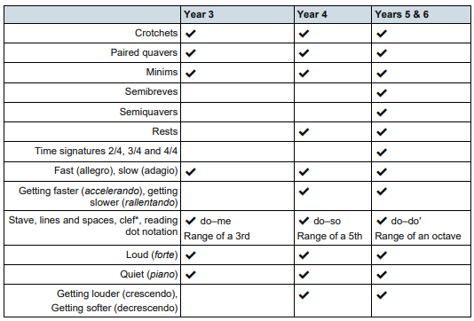
Suggested Music
The pieces listed here are intended to give teachers a good start in terms of choosing music, which is age-appropriate. It should not limit the imagination or creativity of the teacher in terms of seeking and using other musical examples.
Year 1 | 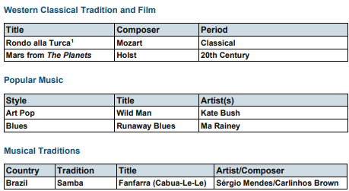
Year 2 | 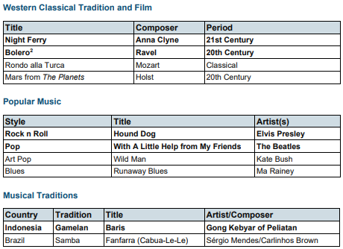
Year 3 | 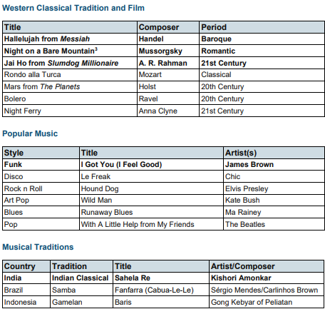
Year 4 | 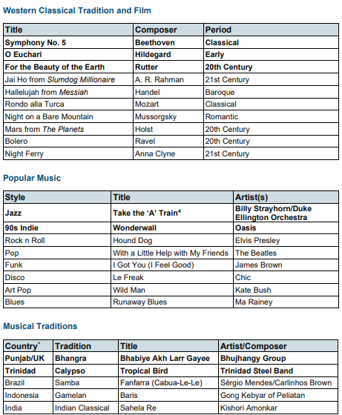
Year 5 | 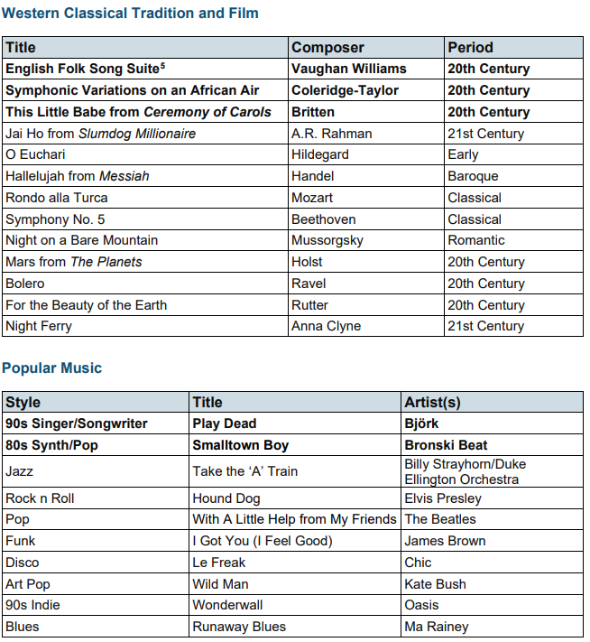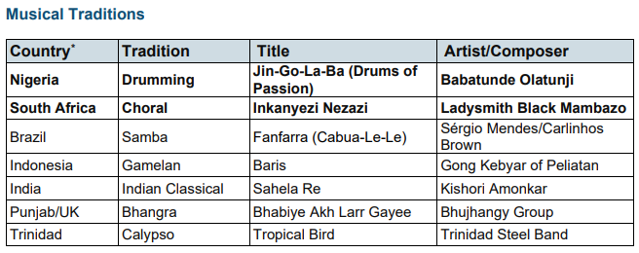
Year 6 | 