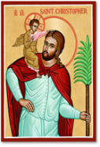
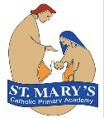
St Mary’s Catholic Primary Academy Curriculum Overview
St Christopher’s Class Advent 2 Year 6
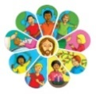  Religious Education  - Other Faiths – Judaism  - Prophecy & Promise | English: Stories written in the 1st person  Reading text: Kensuke’s Kingdom by  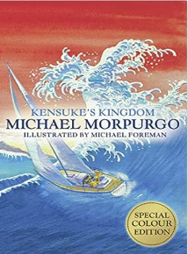  Michael Morpurgo  Writing genres:  Diary Entry  Persuasive Writing  Whole Class Reading Texts:  Kensuke’s Kingdom by  Michael Morpurgo | 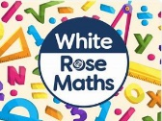  Maths  - Number: Fractions A and B  We will learn to simplify fractions, compare and order them, and perform more complex calculations like adding and subtracting fractions with different denominators, multiplying two fractions, and dividing a fraction by a whole number.  - Measurement: Converting Units  We will solve problems with decimals up to three places, calculating area and volume using formulae, and converting between different units of measurement.
RSHE
- God’s Care for Us
- Body Image (girls’ and boys’ bodies)

  Science: Changing Circuits  We will learn:  - what electricity is and investigate static electricity.  - to recognise and use conventional symbols for circuits.  - ways in which the brightness of a bulb or speed of a motor is changed.  -to plan, carry out and evaluate an experiment to see how changing the wire in a circuit affects the brightness of a bulb.  -create a simple device using a circuit. | Geography: Trading  We will learn:  -that trading is the buying and selling of goods and services.  -goods are objects that people either grow or make e.g. food, clothes and computers.  - that services are these that people do for example banking, communications, health, tourism.  -know some of the main goods/services traded by/with the UK and that these can vary year on year depending on demand and cost.  - some of the main countries the UK export to.  -some of the main countries the UK receives imports from.  - what we mean by energy and why we need it.  -the impact of Brexit on UK trading.  - the impact of the global crisis on UK trading.  - what fairtrade is. | 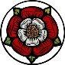  DT: Textiles  In DT, we will learn to:  -talk about what textiles are, their purpose and how they can be joined together.  -design a product in accordance with a specification and design criteria to fit a specific theme.  -sketch and annotate different ideas.  -mark and cut fabric according to a design.  -assemble a product by marking and cutting fabric accurately, in accordance with a design.  - decorate the product by attaching objects using thread and adding a secure fastening.  -evaluate the product according to the design criteria.
  PE  - Tuesdays: Indoor PE  Fridays: Outdoor PE | Key Dates:  - Jack and the Beanstalk Pantomime 28th November  - Christmas Jumper Day 11th December  - Christmas Lunch – 11th December (Order via Willoughby Foods by 2nd December)  - Advent Celebration of the word – 15th December -2.45pm – Families welcome to attend.  - Last day of term 19th December  - Return to school Mon 5th January 2026 |   Music  In Music, we will learn to play scales and chords.
French (KS2):  Healthy Lifestyle |  |   Computing  - Creating media – Web page creation

