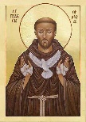
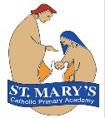
St Mary’s Catholic Primary Academy Curriculum Overview
St Francis’ Class Advent 2 Year 5
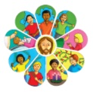  Religious Education  - Life Choices  - Other Faiths (Judaism)  - Hope | English  Reading text: The Snow Sister by Emma Carroll  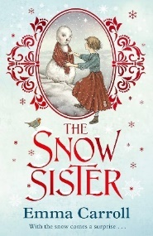  Writing genres:  - Explanation Text (linked to Geography)  - Mystery Stories  - Newspaper Report (linked to Geography) | 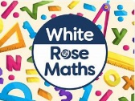  Maths  - Number: Multiplication and Division  - Prime, square and cube numbers  - x and ÷ by 10, 100 and 1000  - Number: Fractions  - Unit and non-unit fractions  - Converting mixed numbers/ improper fractions  - Comparing, ordering and adding them

RSHE

- God’s care for us.
- Body image (changes that girls and boys will experience during puberty)
  Science: WOW Area  - We will explore the forest school to learn some key skills.  - We will be split into 2 groups and will all get to visit the Woodland of Wonder for 1.5 hours each week.  - Please send your child in appropriate clothing on Thursdays with a change of footwear. | Geography: Rivers, Weathering and Erosion  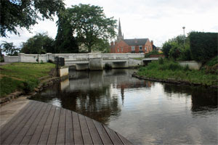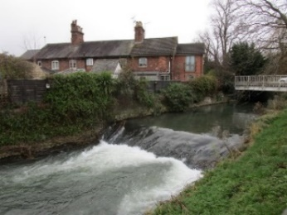  - We will learn about the main rivers in the UK and around the world.  - We will identify its main features and use maps to investigate the River Witham further (to include fieldwork).  - We will explore the environmental impact and consider ways for sustainability. |   DT: Mechanisms – Pop Up Books  In DT, we will learn:  - about the features and purpose of pop up books.  - to design a pop up book of our own, considering the mechanisms to use.  - about the importance of quality in design as well as the aesthetics for a target user.  - to make and evaluate a pop up book.
  PE  - Mondays: Swimming | Key Dates  - Jack and the Beanstalk Pantomime – 28th November  - 10th December 2025 @ 2:45pm – Year 5 Advent Celebration of the Word in school. Families are welcome to attend.  - Christmas Jumper Day – 11th December  - Christmas Lunch – 11th December (Order via Willoughby Foods by 2nd December)  Visits and Visitors  We will be going on a local walk to explore the features and journey of the River Witham through parts of Grantham. Details will be sent out in due course. |   Music  We will learn about:  - using and describing musical terminology (in films).
French (KS2): The Date  We will learn the days of the week, months of the year and numbers to 30. We’ll also be able to ask and answer questions about our birthday. |  |   Computing  Creating Media – Video editing

