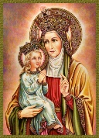
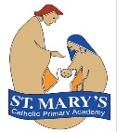
St Mary’s Catholic Voluntary Academy Curriculum Overview Year 4
St Anne’s Class advent Term 2
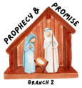  Religious Education:  - Judaism – Other Faith  - Prophecy & Promise | English:  Reading text/Visual literacy:  Varjak Paw by S F Said  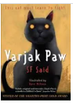  Writing genres:  Diary Entry  Non-chronological Report  Mystery Narrative  Kennings Poetry | 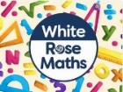  Maths:  Number: Area  Multiplication and Division  Each maths session will start with a mental maths retrieval activity that encourages the children to recap and revise prior learning. We will be looking at times tables ready for our times tables test in June.

RSHE – Get up!
Children will hear and experience the Gospel story of Jesus healing Jairus’ daughter. Children will learn that they are created by God out of love and for love: they were designed for this purpose, which should inform how they live.
Me, My Body, My Health
Children will learn to celebrate similarities and differences, and to appreciate and look after their bodies as gifts from God. They will also learn specific physical and emotional changes during puberty, and that growing from boys and girls to men and women is part of God’s loving plan for creation.
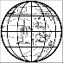  Science:  Electricity  We will have a physics focus as we look at electrical appliances; different ways that electricity is generated; and circuits and conductors. | Geography: The Water Cycle  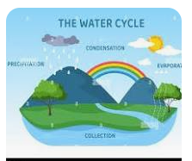  We will be exploring the different parts of the water cycle in detail. We will be looking at evaporation, condensation, precipitation and run off. |   Design Technology: Cooking & Nutrition: Adapting a Recipe  We will be providing opportunities for children to learn a basic biscuit recipe and adapt it to suit a target audience. They will then be evaluating their recipes.
  PE:  - Thursday – Dance (indoor)  - Tuesday – Netball (Outdoor) | Key Dates:  - Jack and the Beanstalk Pantomime 28th November  - Y4 Advent Celebration of the word 8th December – 2.45pm (Families welcome)  - Christmas Jumper Day 11th December  - Christmas Lunch 11th December (Order via Willoughby Foods by 2nd December  - Last day of term 19th December  - Return to school Mon 5th January 2026 |   Music:  Understand the word “pop” and “techno” in music.
French  - Ma Famille (My Family)  We will be learning the names for different family members and how to say their ages. |  |   Computing: Learners will identify the input device (microphone) and output devices (speaker or headphones) required to work with sound digitally. Learners will discuss the ownership of digital audio and the copyright implications of duplicating the work of others.

