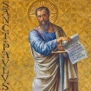
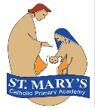
St Mary’s Catholic Voluntary Academy Curriculum Overview
St Paul’s Class Advent 2 Year 3
Religious Education  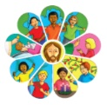  - Judaism – other faiths unit.  - Visitors – Children will be exploring the big question ‘Are visitors always welcome?’ | 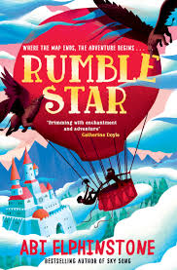  English  Reading text:  - Rumblestar by Abi Elphinstone  In English children will be using our text Rumblestar to create extended pieces of writing linked to the focus genres listed. We will be focusing on using correct punctuation in sentences, spelling KS1 exception words accurately and introducing children to Year 3/4 words. In handwriting, we will be focusing on cursive joins for most letters.  Writing genres:  - Fantasy Stories  - Poetry  - Advertising | 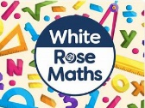  Maths  - Number: Addition and Subtraction  - Using exchange to complete column additions and subtractions.  - Inverse operations  - Adding and subtracting both 2 and 3 digit numbers from a 3 digit number.  - Number: Multiplication and Division  - Using arrays.  - Developing knowledge of the 2, 5, 10, 3, 4 and 8 times table.  - Multiplying and dividing by 2, 5, 10, 3, 4 and 8.

RSHE: TenTen
Module 1: Created and Loved by God:

Created and Loved by God explores the individual. Rooted in the teaching that we are made in the image and likeness of God, it helps children to develop an understanding of the importance of valuing themselves as the basis for personal relationships.
  Science: Forces and Magnets  We will:  - Investigate different forces and how they work.  - Explore different types of magnets, learning about the poles, magnetic field and different metals that they attract.  - Test the strength of different magnets. | 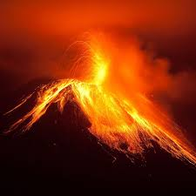  Geography: Volcanoes, earthquakes, Tsunamis  In geography, children will be exploring:  - The different layers of the earth.  - How tectonic plates work and what they cause.  - How volcanoes are formed and where we can find them.  - How earthquakes occur and the effects they have e.g. tsunamis. |   DT: Structures  In DT we will:  - Understand different structures are suitable for different purposes.  - Learn about the qualities of a good structure.  - Create our own nets.  - Use our knowledge of structures and nets to design, make, create and evaluate our own castles.
  PE  Mondays:  - Children will be developing their gymnastics skills, focussing on how they travel and different balances they can make.  Thursdays:  - Children will be developing their cricket skills, beginning to understand the basic rules and the different roles e.g. batter, fielder, umpire. | Key Dates - Visits and Visitors  - Jack and the Beanstalk Pantomime 28th November  - Year 3 – Advent Celebration of the word 1st December 2.45pm (Families Welcome)  - Christmas Jumper Day 11th December  - Christmas Lunch – 11th December (Order via Willougby Foods by 2nd December  - Last day of term 19th December  - Return to school Mon 5th January 2026 |   Music:  Children will be learning how to:  - Read from stave notation – from E to F on a Treble Clef.  - Read rhythm notation.  - Associate the correct names for lengths of notes.
French (KS2): ‘Animals’  Children be able to recognise, recall, remember and spell up to 10 animals in French. |  |   Computing: Creating Media – Animation  Children will use a range of techniques to create a stop-frame animation using tablets, before creating a story-based animation.

