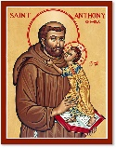
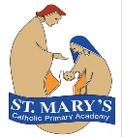
St Mary’s Catholic Primary Academy Curriculum Overview Year 2
St Anthony’s Class advent Term 2
Religious Education:  Branch 2 – Prophecy and  Promise | English: Traditional Tales  Reading text/Visual literacy: Little Red by Bethan Wollvin  Goldilocks – A Cautionary Tale by Tony Ross  Writing genres: Story Writing, Acrostic Poetry, Recount.  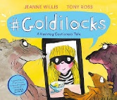  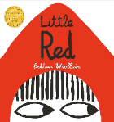  Whole Class Reading Texts:  The Magic Finger – Roald Dahl  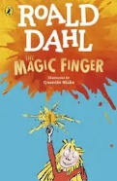 | 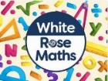  Maths:  Number- Addition and Subtraction  Geometry - Shape  Each maths session will start with a mental maths retrieval activity that encourages the children to recap and revise prior learning. One session each week will also develop their maths fluency and problem-solving strategies.

RSHE – This term Me, My Body, My Health encourages children to celebrate similarities and differences between people, including our God-given bodies and the things they enable us to do! Teaching also includes maintaining personal hygiene and the physical differences between boys and girls.
  Science:  Exploring Everyday Materials  The children will be identifying and sorting materials. They will then be looking at man-made and natural materials. We will also be looking at how materials change when they are squashed, bent, twisted or stretched. The children will use this knowledge to work out which materials are suitable. | 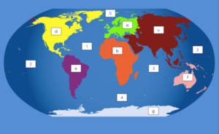    Geography: Our World  Pupils will be finding out about, and locating, the different continents, oceans and climates. Then they will research the flora and fauna that inhabit those areas. |   DT: ‘Textiles’  The children will be learning to thread a needle and sew a simple running stitch. They will be understanding the importance of joining fabrics securely together and will make an item ready for Christmas.
  PE:  - Wednesday – Inside (Gymnastics)  - Friday – Outside (Ball skills) | Key Dates:  - Jack and the Beanstalk Pantomime 28th November  - Christmas Jumper Day 11th December  - Christmas Lunch – 11th December (Order via Willoughby Foods by 2nd December)  - Nativity – 18th December 2pm (All welcome)  - Last day of term 19th December  - Return to school Mon 5th January 2026 |   Music: Children will be using Hip Hop music to extend their knowledge and will learn a Christmas rap.
Computing: Creating Media - Digital Photography.
Pupils will learn to recognise that different devices can be used to capture photographs and will gain experience capturing, editing, and improving photos.

