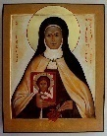
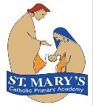
St Mary’s Catholic Primary Academy Curriculum Overview
St Thérèse of Lisieux Class Advent 2 Reception
  Religious Education  - Judaism  - Birthdays | English: Talk4writing  Elmer  Rhymes and poems  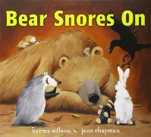  Reading texts: Squirrels busy day  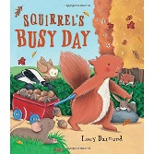  Bears snores on  The busy little squirrel  Writing genres:  Labels and lists  Story maps  Rhymes and patterns  Whole Class Reading Texts:  The nutty nut chase  After the storm |   Maths  It’s Me!  Find, subitise and represent 1, 2 and 3. 1 more/1 less. Composition of 1, 2 and 3  Circles and triangles  Identify, compare circles and triangles  Shapes in the environment  Describe position  1,2,3,4,5  Find, subitise and represent 4 and 5.  1 more/less  Composition of 1-5  Shapes with 4 sides  Identify, name and combine shapes with 4 sides  Shapes in the environment. My day and night

RSHE
Religious understanding
- Me, My Body, My Health
- Emotional Well-Being
- Life Cycles

PE
- Tuesdays: Gymnastics
- Thursdays: WOW area
  Science: Celebrations  We will learn about:  - natural world around us, making observations and drawings  - understand some of the important processes and changes in the natural world | Geography: Weather & Seasons  Habitats & environment    - We will explore the natural world around us  - What our home is like and our address  - Look where we live and go to school  - Explore the local environment (school grounds) | 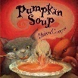  DT:  In DT we will be:  - SOUP - Explore the differences between fruits and vegetables using their senses (taste, texture, smell etc.). Listen to the story ‘The best pumpkin soup’ and discuss the key ingredients the characters used before developing a class-based vegetable soup recipe.  - Healthy and unhealthy foods.
- Phonics  - Recap on set 1  - special friends: th, ch, qu, ng, nk  - Children are taught to blend sounds into words orally.  - Children are taught to blend single-letter sounds (word time 1.1-1.4) | Key Dates - Visits and Visitors  - Visiting ASDA/Green grocer 7th November  - Visiting Church 18th November  - Jack and the Beanstalk Pantomime – 28th November  - Christmas Jumper Day 11th December  - Christmas lunch 11th December (Order via Willoughby Foods by 2nd December  - Nativity 17th December - 09:30am  - Last day of term 19th December  - Return to school Mon 5th January 2026 |   Music  - Sing in a group or on their own, increasingly matching the pitch and following the melody.

Computing
Computing systems & Networks
- How to keep myself safe online

